Name and Student ID: Riley Lawson rjlawson@iastate.edu Lab Section: 6

Date: 10/7/2020

# Submission Instructions:

## Prelab:

1. Complete the prelab
2. Submit this report with the prelab completed to Canvas **before** your lab starts

## Lab:

1. Complete the lab according to the instructions
2. Take screenshots of your ModelSim waveform (note: to receive points your NetID has to be present in the screenshot) and insert them into this document.
3. Include screenshots of any related block design files or Verilog files in the report
4. Complete this report and reupload it to Canvas

**PRELAB:**

Read the Mini-Project lab document and complete as much of this answer sheet as you can before lab.

**LAB:**

**4.0** Draw Uncle Bob’s circuit below, using only AND, OR, and NOT gates.

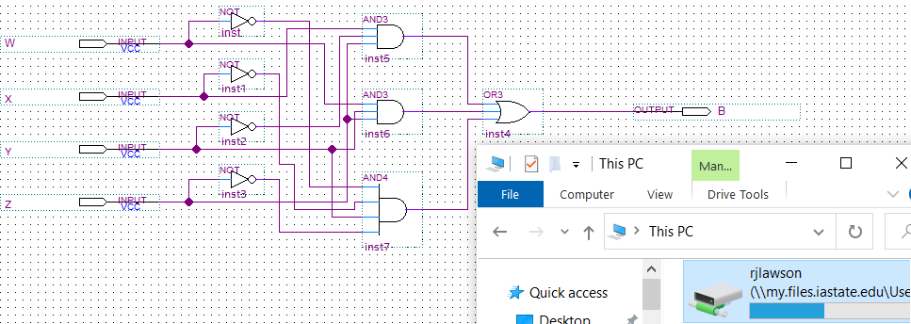

**5.0** Give the shorthand canonical SOP expression for Uncle Bob’s circuit and write the Verilog code which implements this behavior:

**B(W, X, Y, Z)**  **=** ∑m(2, 5, 11, 13, 15)

**Verilog:**

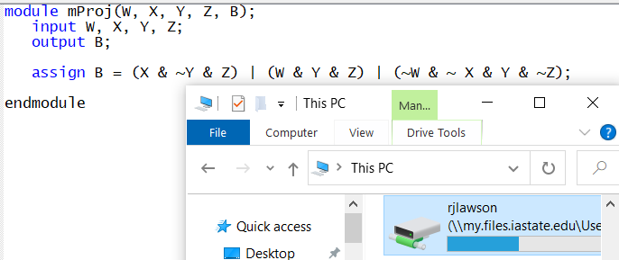

Part 5.0 Results:

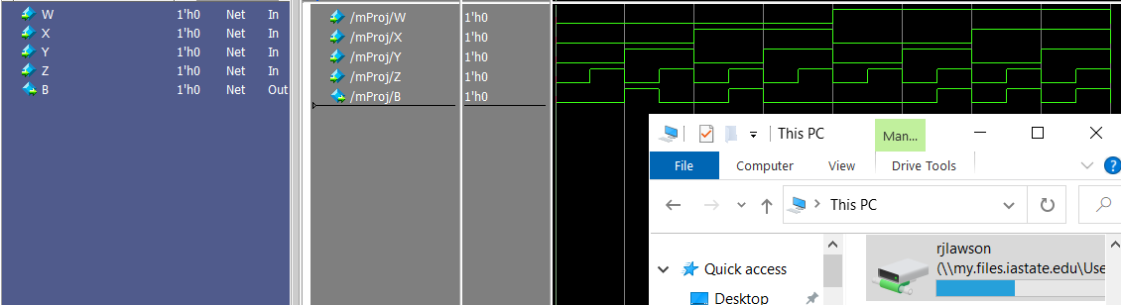

**6.0** Truth table for Uncle Bob’s function B and the 4-bit prime detector function P.

|  |  |  |  |  |  |  |  |  |  |  |  |  |
| --- | --- | --- | --- | --- | --- | --- | --- | --- | --- | --- | --- | --- |
| **W** | **X** | **Y** | **Z** | **B** | **P** |  |  |  |  |  |  |  |
| 0 | 0 | 0 | 0 | 0 | 0 |  |  |  |  |  |  |  |
| 0 | 0 | 0 | 1 | 0 | 0 |  |  |  |  |  |  |  |
| 0 | 0 | 1 | 0 | 1 | 1 |  |  |  |  |  |  |  |
| 0 | 0 | 1 | 1 | 0 | 1 |  |  |  |  |  |  |  |
| 0 | 1 | 0 | 0 | 0 | 0 |  |  |  |  |  |  |  |
| 0 | 1 | 0 | 1 | 1 | 1 |  |  |  |  |  |  |  |
| 0 | 1 | 1 | 0 | 0 | 0 |  |  |  |  |  |  |  |
| 0 | 1 | 1 | 1 | 0 | 1 |  |  |  |  |  |  |  |
| 1 | 0 | 0 | 0 | 0 | 0 |  |  |  |  |  |  |  |
| 1 | 0 | 0 | 1 | 0 | 0 |  |  |  |  |  |  |  |
| 1 | 0 | 1 | 0 | 0 | 0 |  | P |  |  |  |  |  |
| 1 | 0 | 1 | 1 | 1 | 1 |  |  | WX  YZ | 00 | 01 | 11 | 10 |
| 1 | 1 | 0 | 0 | 0 | 0 |  |  | 00 | 0 | 0 | 0 | 0 |
| 1 | 1 | 0 | 1 | 1 | 1 |  |  | 01 | 0 | 1 | 1 | 0 |
| 1 | 1 | 1 | 0 | 0 | 0 |  |  | 11 | 1 | 1 | 0 | 1 |
| 1 | 1 | 1 | 1 | 1 | 0 |  |  | 10 | 1 | 0 | 0 | 0 |

Simplified SOP Expression:

**P(W, X, Y, Z)** **=** !W!XY + !WXZ + !XYZ + X!YZ

**7.0** Give your implementation of the correct 4-bit prime detector circuit (**P**) below as either Verilog or a schematic (your choice). Then demonstrate the results:

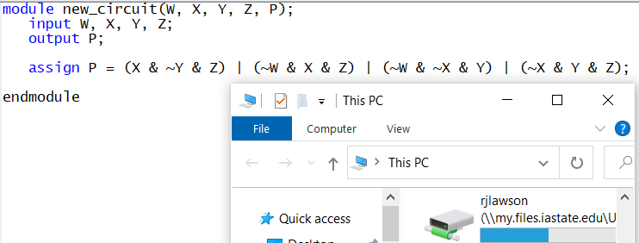

Part 7.0 results:

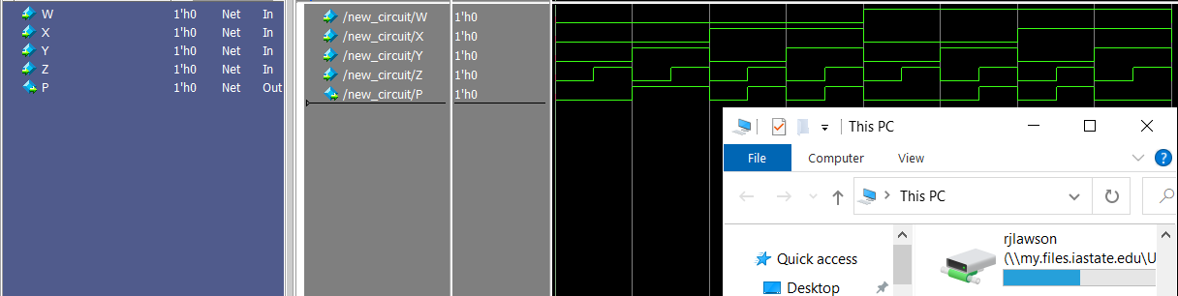

**8.0** Design and implement a circuit that uses Uncle Bob’s circuit but fixes his mistakes. Draw it below and demonstrate the results:

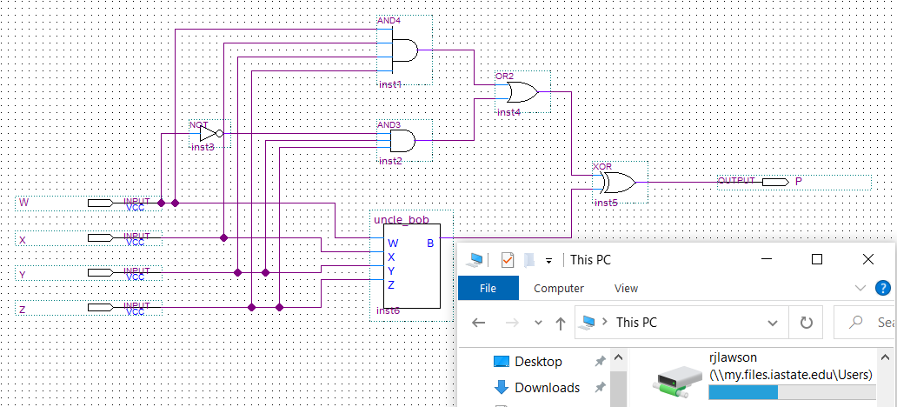

Part 8.0 results

